The SAFE-Archive System
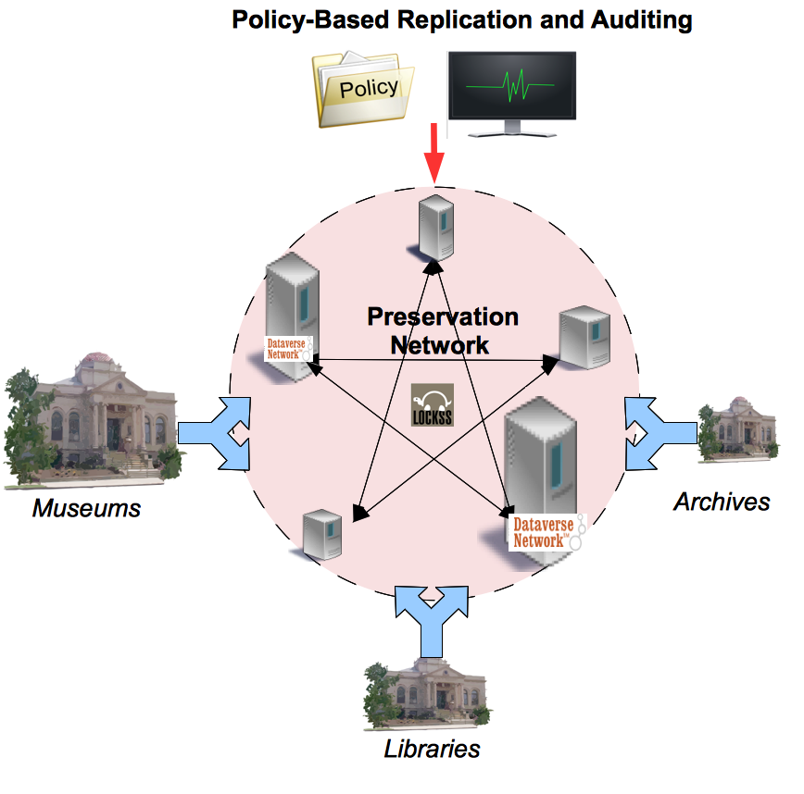
[www.safearchive.org]
The SAFE Archive system is an open-source system for TRAC auditing and policy-based automatic management of LOCKSS replication networks.
With SAFE archive you can:
- Analyze any LOCKSS network
- Check that collections are replicated, valid, and up-to-date
- Create formal replication policies
- Audit the network for current and historical TRAC compliance
- Replicate content archived in the Dataverse Network easily
Coming this summer, SAFE-archive will:
- Automatically manage and repair a LOCKSS network based on your replication policy
Summary: Geographically- and organizationally- distributed replication of content is vital to insure against archival failures. The SAFE-Archive system provides an automated, policy-based, auditable tool to facilitate robust replication across institutional partners. The goal of the system is to allow anyone to audit existing preservation networks and to enable groups of institutions to easily collaborate to replicate and preserve their collective content.
Partner Organizations: The project is a collaborative effort of the Data-PASS Partners: The International Consortium for Political and Social Research, U. Michigan; The Roper Center for Public Opinion Research, Research at the University of Connecticut, the Howard W. Odum Institute at the University of North Carolina-Chapel Hill, NARA, and the Institute of Quantitative Social Science, Harvard University. It is managed through the Institute of Quantitative Social Science, and works in collaboration with the LOCKSS project at Stanford University.
Sponsor: The project is sponsored by the Institute of Museum and Library Services (IMLS), under award #LG-05-09-0041-09.
Website: http://safearchive.org
Contact: Micah Altman (<Micah_Altman@harvard.edu>)
