Data Management Tool Launched on November 1, 2011
http://dmp.cdlib.org
Important questions are challenging researchers today: Where should their research data reside? How can they make the data discoverable by other investigators and repurposed in new ways? Would allowing others to access the data help advance their fields or their careers?
Several major research institutions* have partnered to develop the DMPTool, a flexible online application to help researchers generate data management plans, simple but effective documents for ensuring good data stewardship. These plans are increasingly being required by funders such as the National Science Foundation (NSF), the National Institutes of Health (NIH), and the Gordon and Betty Moore Foundation (GBMF). The DMPTool supports data management plans and funder requirements across the disciplines, including the humanities and physical, medical, and social sciences.
“Many funding agencies require a data sharing plan be included in their applications. How to accomplish this is a challenge for our Principal Investigators, given that retention of research data is now much more than retaining all original notebooks, but includes storing of massive amounts of electronic data…The availability of the new Data Management Planning Tool will prove invaluable in assisting them in the management of their data and complying with these agency requirements,” states Charles Louis, Vice Chancellor for Research, UC Riverside.
The DMPTool is open-source, freely available, and easily configurable to reflect an institution’s local policies and information. Users of the DMPTool can view sample plans, preview funder requirements, and view the latest changes to their plans. It permits the user to create an editable document for submission to a funding agency, and can accommodate different versions as funding requirements change. Not only can researchers use the tool to generate plans compliant to funder requirements, but institutions can also use the tool to present information and policies relevant to data management and to foster collaboration among faculty, the institutional libraries, contracts and grants offices, and academic computing.
William (Bill) Michener, Professor and Director of e-Science Initiatives for the University Libraries, University of New Mexico, and DataONE Principal Investigator, states “The requirements from NSF and other funding agencies for data management and sharing will lead to new and better science by promoting data stewardship and encouraging data sharing. The DMPTool is an important resource for researchers as they develop funding proposals, and gives them a full picture of all aspects of sound data management practice.”
*Project partners include the University of California Curation Center (UC3) at the California Digital Library, the UCLA Library, the UCSD Libraries, the Smithsonian Institution, the University of Virginia Library, the University of Illinois at Urbana-Champaign, DataONE, and the United Kingdom’s Digital Curation Centre (DCC). Working collaboratively, these institutions have consolidated their expertise and reduced their costs.

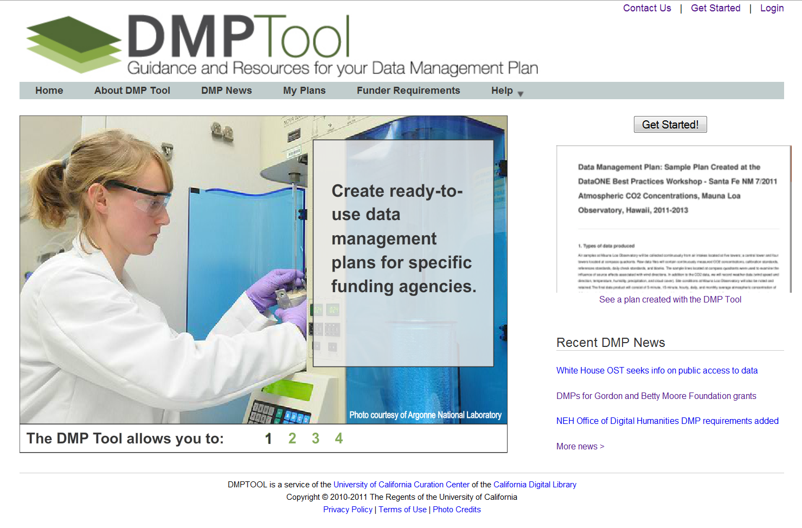
DMPTool Front Page
http://dmp.cdlib.org

