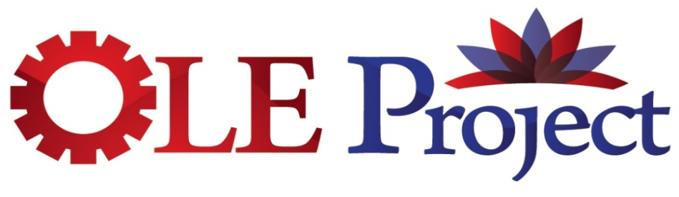
The Open Library Environment Project
http://oleproject.org

The design phase of the OLE Project will be completed by July 2009 and is at a critical point from a “progress made” perspective, and a project timing perspective. Participants anticipate moving into a build project this summer if funding is secured. At this point in the design phase, it is critical to discuss the outcomes of work to-date with a wide spectrum of the community’s leadership (both Library and IT), and engage the community in a discussion regarding the potential level of support for, and involvement in, the build project.

A successful OLE Project will impact the ability of library management systems to move from more self-contained “niche” applications into a broader services-based, enterprise-level environment providing new functions and long-term benefit for the academic and research community. However, without both Library and IT involvement with the project goals and approaches, it will not be successful moving forward. OLE Project needs your input!

Potential Questions for Discussion

- How is this project important to your institution?
- What are the improvements OLE would offer your institution?
- What are issues/barriers for transitioning to OLE?
- What are the costs/risks of not moving ahead with OLE?
- What do you see as critical factors for the project moving forward?
- How should continuing support from the community be solicited?

Background Information

What: With support from The Andrew W. Mellon Foundation, a multinational group of libraries is developing the design for an Open Library Environment (OLE), a framework for the next generation of library automation services based on open-source licensing and using Service Oriented Architecture (SOA) and Business Process Modeling (BPM) principles. The goals for this phase of the project are to provide a high level design document for the OLE framework and to develop a community of interest which can build, implement and sustain the technology defined in that framework.
http://library.duke.edu/about/projects/oleproject/wp-content/uploads/2008/06/ole_projectdescrip_web1.pdf

Who: The Project is guided by a group of Core and Advisory Partners comprised of:
Columbia University Duke University Indiana University
Lehigh University Library and Archives Canada National Library of Australia
OhioLINK Orbis Cascade Alliance Rutgers University
University of Chicago University of Florida University of Kansas
University of Maryland University of Pennsylvania Vanderbilt University
Over 290 other libraries and organizations have participated in the planning process through workshops, webcasts and/or working groups. http://oleproject.org/workshops , and http://oleproject.org/category/documents/bpm-project-meeting

Timeline: Design phase - September 2008 through July 2009 (http://oleproject.org/overview/project-timeline)

Approach:
- Design based on Service Oriented Architecture & Business Process Modeling principles
  - Goal: Analyze & design standardized higher-level workflows for major library operations
- Webcasts and regional workshops; project presentations at open conferences & meetings
  - Goal: Gather broad community input to inform system design
- Working meetings of partners
  - Goal: Develop project principles; conduct workflow analysis; produce BP specifications
- Creation of design document to inform further development
- Development of Build Phase proposal

OLE Project Activities & Plans (http://oleproject.org/overview/project-timeline)
- Bi-weekly conference calls for Core & Advisory Partners
- 1st in-person meeting held at Duke University in September
  - Training in SOA principles and approaches
  - Scope document refinement
  - Community participation planning
- 2nd in-person meeting held in November at Rutgers University
  - Training on Business Process Modeling (BPM) methodologies
- Regional workshops to gather input on business processes (Dec/Jan.) (outcomes available on website)
- 3rd in-person meeting held in January at Lehigh University
  - Reference model developed
  - Initial process models identified
  - Initial discussion on governance models
- Small groups working online to develop and refine process models (use links below OR click on “bubbles” in the OLE Modules section of the Reference Model for more detailed models)
  - Acquire Resources
  - Resource Description
  - Resource Delivery
  - Functionality from Other Systems
- 4th in-person meeting scheduled for March at University of Kansas
  - Further definition & refinement of process models
  - Begin work on environmental, functional, & technical specifications
  - Begin outlining final document
- Final in-person meeting scheduled for May at Duke University
- Presentations done or upcoming at a number of local and national meetings
- Several open webcasts held, both on OLE and related projects
- Draft report out for general comment & review late Spring
- Report / design document due in July 2009
- Proposal for Build Phase to be completed late Spring / early Summer

