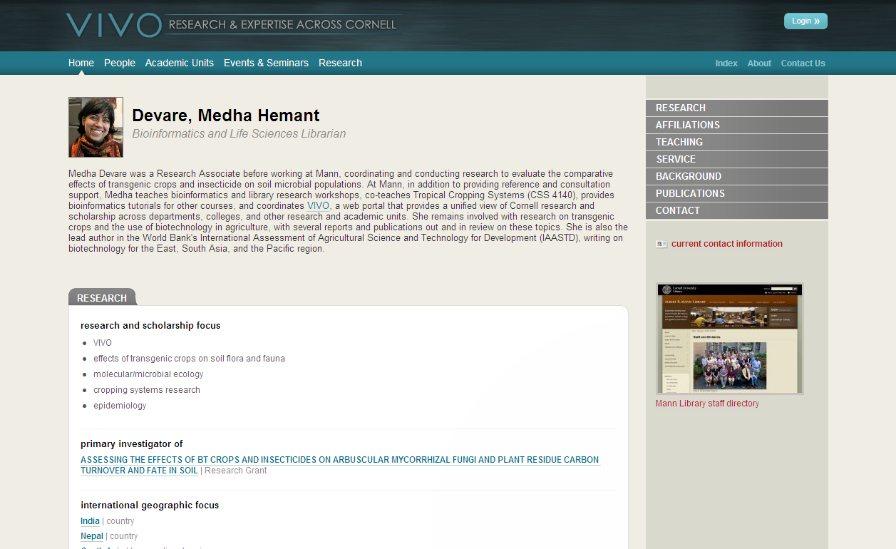
VIVO -- Research and Expertise Across Cornell
VIVO helps researchers to discover each other, facilitating communication and collaboration across interdisciplinary and institutional boundaries.
VIVO helps prospective and current students and employees, administrators, donors, funding agencies, and the public find comprehensive, authoritative information about Cornell research and scholarship.
VIVO is …
A semantic web application that enables the discovery of research and scholarship across disciplines in an institution
Populated with detailed profiles of faculty and researchers; displaying items such as publications, teaching, service, and professional affiliations
A powerful search tool for locating people and information within or across Cornell’s departments, colleges, and campuses

VIVO includes all disciplines at Cornell and provides:
- The VIVO website (http://vivo.cornell.edu) for searching and browsing
- Filtered views - Graduate Programs in the Life Sciences, CALS Research portal
- Repurposing of data for unit web sites (College of Arts and Sciences)
- Self-editing capability and staff editing privileges for departments or centers
- Library curation and reference question response by disciplinary specialists
- Active collaboration with Weill Cornell Medical College.

Ongoing Work

Within Cornell University
- Closer integration of VIVO and VIVO data into Cornell University’s web presence
- Automated data ingest and update for courses, HR appointments, grants, and faculty reporting (Activity Insight)
- Documented templates for consuming VIVO data in common Web formats

At the national level¹
- Visualizations of complex publication and research networks and relationships for individual researchers, institutions, and national trends – within VIVO!
- Supplemental authoritative external data for publications and grants
- Improved search extending beyond Cornell to other institutions
- Support from external applications, e.g., to generate biosketches

Sites using VIVO at Cornell University
VIVO Cornell | http://vivo.cornell.edu
Graduate Programs in the Life Sciences | http://grad.lifesciences.cornell.edu/
Entrepreneurship @ Cornell | http://eship.cornell.edu/
CALS Impact and Research | http://impact.cals.cornell.edu
Faculty profiles (example) | http://classics.cornell.edu

NIH-funded VIVO Project Institutions¹
University of Florida  Development focus: authentication, data ingest | http://vivo.ufl.edu
Cornell University  Development focus: core application and semantics | http://vivo.cornell.edu
Indiana University  Development focus: visualization, social networking | http://vivo.iu.edu
Ponce School of Medicine | http://vivo.psm.edu
The Scripps Research Institute | http://vivo.scripps.edu
Washington University, St. Louis | http://vivo.wustl.edu
Weill Cornell Medical College | http://vivo.med.cornell.edu

International sites using VITRO (code-base for VIVO)
ANDS-Vitro Consortium (Griffith, QUT, University of Melbourne, VeRSI) | http://ands.org.au/resource/solutions.html
Chinese Academy of Sciences (3 sites) | http://ske.las.ac.cn

Other sites piloting or adopting VIVO technology
Arizona State University, Duke University, IICA, Los Alamos National Laboratory, Northwestern University, Stony Brook University, University of Arkansas, University of Buffalo, University of Colorado – Boulder, University of Delaware, University of Oregon, University of Virginia, USDA

Integration partners
APA (Digital Trust), Duke (Widgets), Harvard University (Harvard Profiles), Indiana University (HUBzero), Orchid, Stony Brook University (UMLS), University of Hong Kong (Knowledge Exchange), University of Pittsburgh (Digital Vita), Weill Cornell Medical College (Google Refine).

Contact Information

Jon Corson-Rikert
jc55@cornell.edu ~ http://vivo.cornell.edu/individual/vivo/CramerEllenJ

Ellen J. Cramer
ejc12@cornell.edu ~ http://vivo.cornell.edu/individual/vivo/individual22972

Leslie McIntosh
lmcintosh@path.wustl.edu ~ http://vivo.wustl.edu/display/hrfact1280951568

