Gaming at the Undergraduate Library
Visit us on the web for more information and news updates at: http://www.library.uiuc.edu/gaming/
Or Email:
dh-ward@uiuc.edu
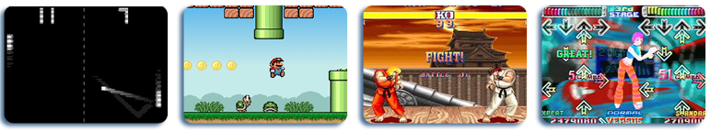

The Mission
The UIUC Gaming collection was created to support a wide variety of campus interdisciplinary programs, scholarly research, and student needs involving video games.

What’s available?
- Console Games (XBox, XBox 360, Playstation 2 and 3, Nintendo WII, etc.)
- Handheld Games (Nintendo DS, PSP, etc.)
- PC Games
- Examples of vintage consoles and games (Atari 2600, Sega Genesis, Nintendo 64, etc.)
- Donations welcome!

What Books and other literature does UIUC have on gaming?

Magazines and Journals:
- Games & Culture: A Journal of Interactive Media
- The Journal of Game Development
- Electronic Gaming Monthly (EGM)
- Computer Gaming World

Books:
- Digital play: the interaction of technology, culture, and marketing by Stephen Kline, Nick Dyer-Witheford, and Greig de Peuter. (794.8 K685d )
- Game On: The History and Culture of Videogames edited by Lucien King (794.8 G1452)
- Got Game: How the Gamer Generation is Reshaping Business Forever by John C. Beck and Mitchell Wader (794.8 B388g)
- Half-Real: Video Games Between Real Rules and Fictional Worlds by Jesper Juul (794.8 J987h)
- Mind at Play: The Psychology of Video Games by Geoffrey R. Loftus & Elizabeth F. Loftus (794.019 L827M)
- Playing With Fire: How Do Computer Games Influence the Player? by Simon Egenfeldt-Nielsen & Jonas Heide Smith (794.8019 Eg21p)
- Supercade: A Visual History of the Videogame Age, 1971-1984 by Van Burnham (794.8 B935s)
- See more on our website!

Want to find a gaming group on campus?

Here are just a few examples (more on our website!):
- Video Gamers Alliance: a group dedicated to the games out on market and from the past
- DDR Illini:The dance games community at the University of Illinois - Urbana/Champaign. This club hosts tournaments and contests, but the main purpose of the club is for DDR players here to be able to have a common ground on which to meet.

And on Facebook…
- Gamers: You know those things you play to pass the time? This is your group. While not strictly a video gaming group, there may be a bit of a bias towards those games of an electronic nature.
- Arcade Game Lovers: This is a group for fans of classic arcade games. Whether you're a fan of Pacman, Galaga, of even Pole Position this group is for you. Join to discuss your favorite games, compare high scores or just talk games in general.

Looking for gaming events to attend?
- The library regularly hosts Gaming Nights. Stay tuned to the UGL homepage or Gaming website for details
- The Illinites group (at the Union) also host gaming nights. Check our website often for updates on new tournaments!
- Many of the gaming groups and RSOs on campus host gaming activities as well.

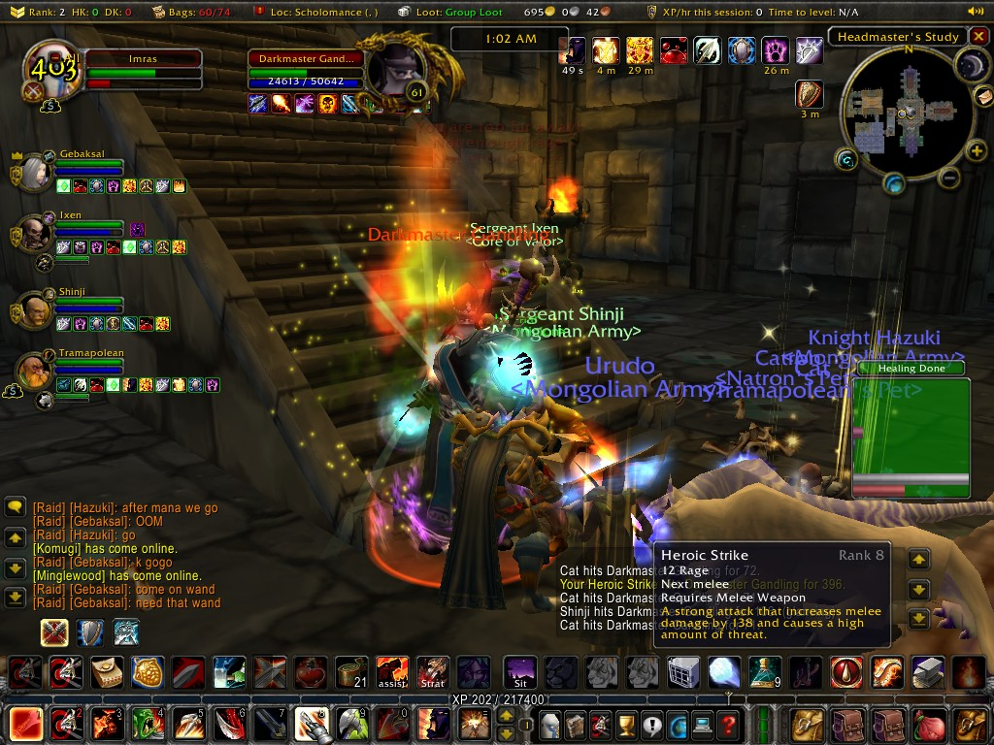

Gaming at the Undergraduate Library

http://www.library.uiuc.edu/gaming/

