Developing a Customized, Extensible Application for Digital Collections
Suzanne E. Thorin, Sean M. Quimby, Jeremy D. Morgan, Syracuse University Library

Project Background

As Syracuse University Library reported at the 2011 Coalition of Networked Information meeting, it planned to develop a custom PHP/MySQL database driven application as part of its National Endowment for the Humanities-funded Marcel Breuer Digital Archive project. The application generates METS (Metadata Encoding and Transmission Standard) encoded objects and EAC (Encoded Archival Context) authority records which are, in turn, indexed by the open source eXtensible Text Framework (XTF) platform developed by the California Digital Library. In spring 2012, Syracuse University Library launched the Breuer web portal, which unites more than 35,000 digital objects from nine institutions located in three different countries relating to the influential Bauhaus-trained modernist architect. The project was a model of institutional collaboration, particularly in the realm of copyright policy. Now, Syracuse is extending both the copyright policy and the technological infrastructure developed for Breuer project to all of its digital collections, migrating them from CONTENTdm to the new custom application. In the process, the library will make the content digitized at the request of individual patrons publicly available for the first time. In this presentation, the Syracuse team will provide an overview of its custom database application, demonstrate the completed Breuer portal, and describe in detail its process for migrating the library’s digital objects and metadata from a proprietary system to an open source repository that allows faceted browsing and, eventually, dynamic interoperability with EAD-encoded archival finding aids.

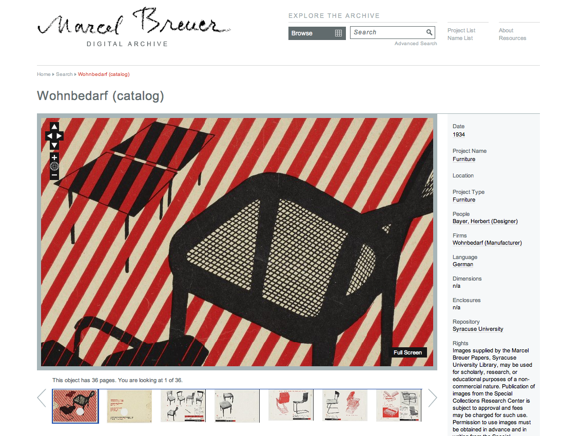
Screen capture of digital object (furniture catalog) from the Marcel Breuer Digital Archive (http://breuer.syr.edu/).
Technical Infrastructure
This digital library project can be broken down into three separate technical systems: METS Database Application, XTF Index and Frontend, and the various independent media servers.

METS Database Application: Custom built on PHP/MySQL and running on Apache, the METS Database Application serves as the central repository of all non-indexed metadata. Raw media and object metadata is initially imported into the database from XML files or tab delimited spreadsheets. All authority metadata and images are linked during the import process. The application’s database and interface is currently being refreshed to be able to accommodate a more diverse collection base. The application also facilities the export of METS and EAC XML for use in the XTF Index.

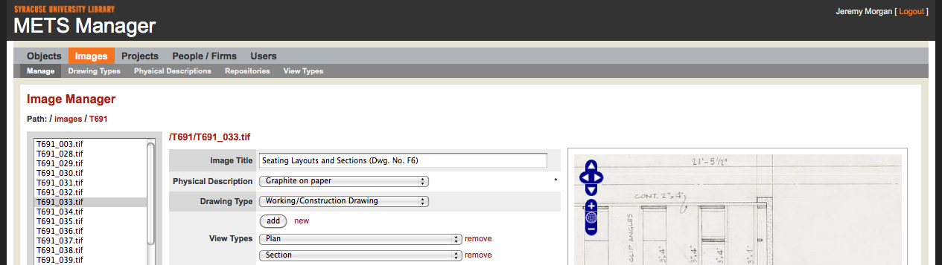
Screen capture of the METS Database Application
eXtensible Text Framework (XTF): Java based and running on Tomcat, XTF is able to index and disseminate numerous types of flat file data formats. The default indexing rules are very limited out-of-the-box, new and further customized XSL rules have since been written to accommodate indexing of METS, EAD, EAC, and MARC XML.

Media Servers: XTF by default does not provide any media streaming solutions. XTF is however very easy to customize and many open source and free media streaming solutions exist. Djatoka, a Tomcat based image server, was adapted for use in the Marcel Breuer Digital Archive and Plastics Collection which enabled the dynamic generation of small, lower resolution JPEG images from large high resolution JPEG2000 files. Future collections will be using the fastCGI based IIPImage server which will provide the same type of dynamic image streaming as Djatoka while enabling better support for watermarking and should be less taxing on server resources. Additional streaming servers will be incorporated to handle the audio and video streaming needs of our other digital collections.
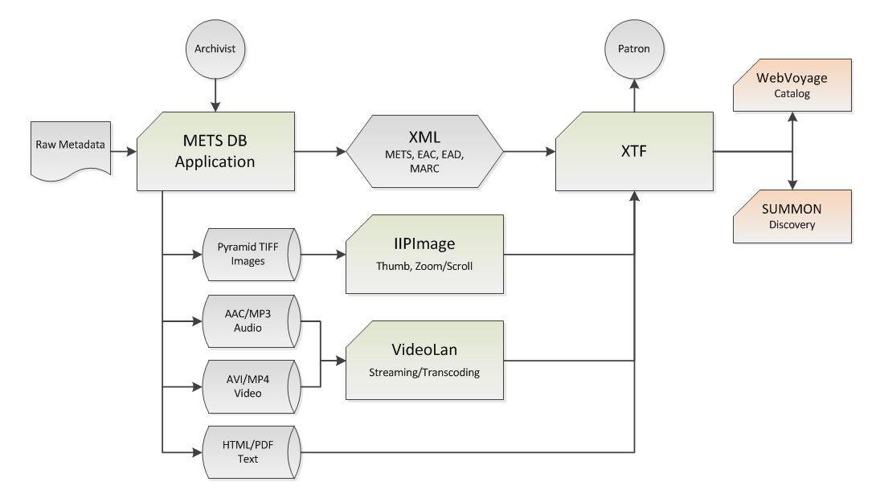
Diagram of the METS/XTF Digital Collection System

Contacts

Suzanne E. Thorin, Dean of Libraries and University Librarian, sethorin@syr.edu
Sean M. Quimby, Senior Director of Special Collections, smquimby@syr.edu
Jeremy D. Morgan, Information Technology Analyst, jdmorgan@syr.edu

